**Week 4 Solutions**

Spring REST using Spring Boot 3

1. spring-rest-handson :-

**Hands on 4**

**Spring Core – Load Country from Spring Configuration XML**

The code and the folder structure is attached in the **spring-learn Ex-2** folder

**Output :-**

**Command** – mvn clean install :-

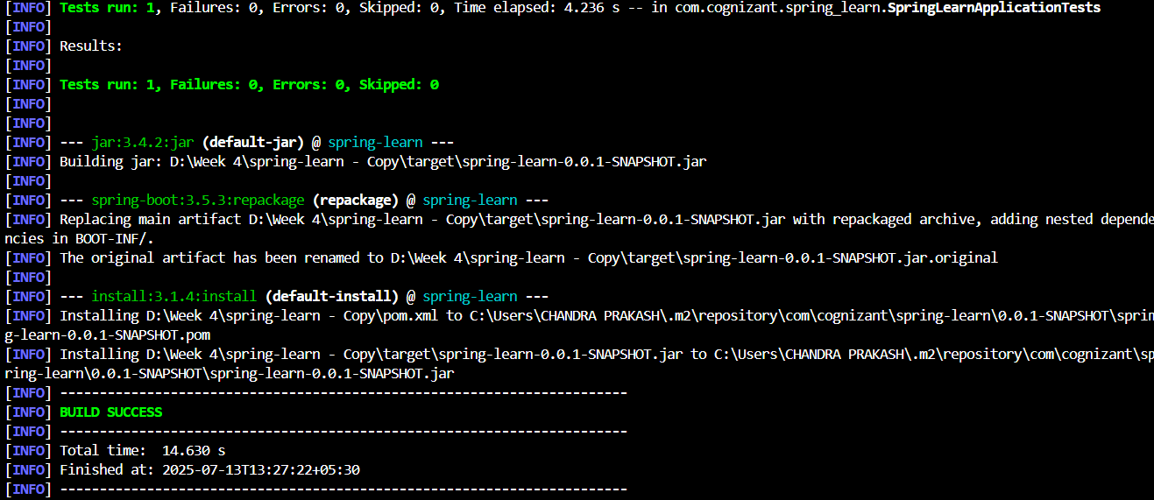

**Command -** mvn exec:java

